**Module 5 Assignment(ACCESS)**

Data Source 1: Access table

The problem describes the use of Pentaho Data Integration Software and Oracle Database.

I have used both.

First Access File is loaded

1. Check Fields Null or not (Filter Rows)
2. Check If is has proper data types (DataValidator)
3. Check Foreign Key References (Doing Sort and Merge at each step)(Transformation Image)

Filter Rows

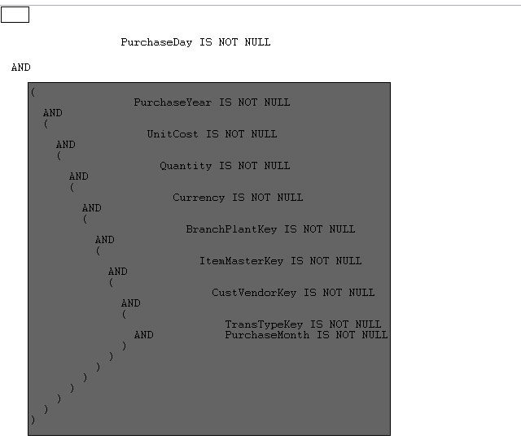

DataValidator (Check Data Type)

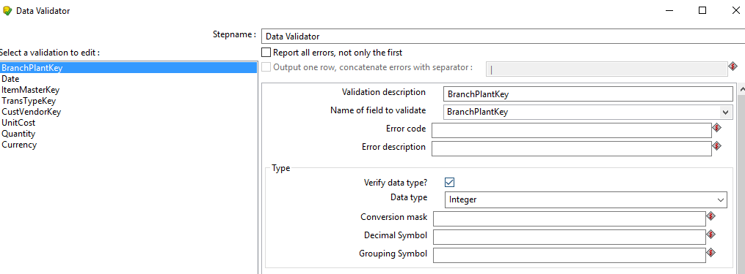

Transformation:

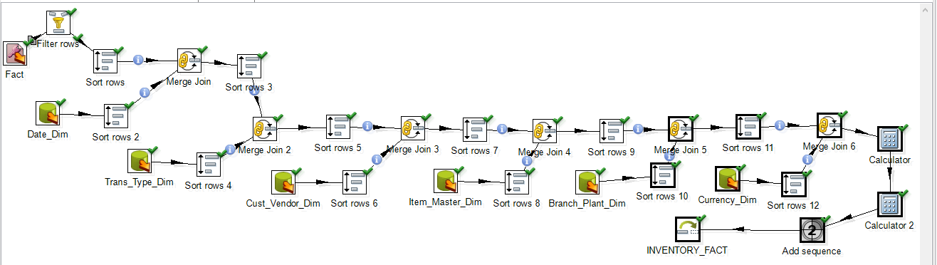

Here Calculator1, Does Unit_Cost(To be inserted) = Unit_Cost in Data Source * Exchange_Rate

Here, Calculator2, Does EXT_COST = Unit_Cost(New one calculated in Calculator1) * Quantity

After running the above, Transformation,11 rows were inserted.

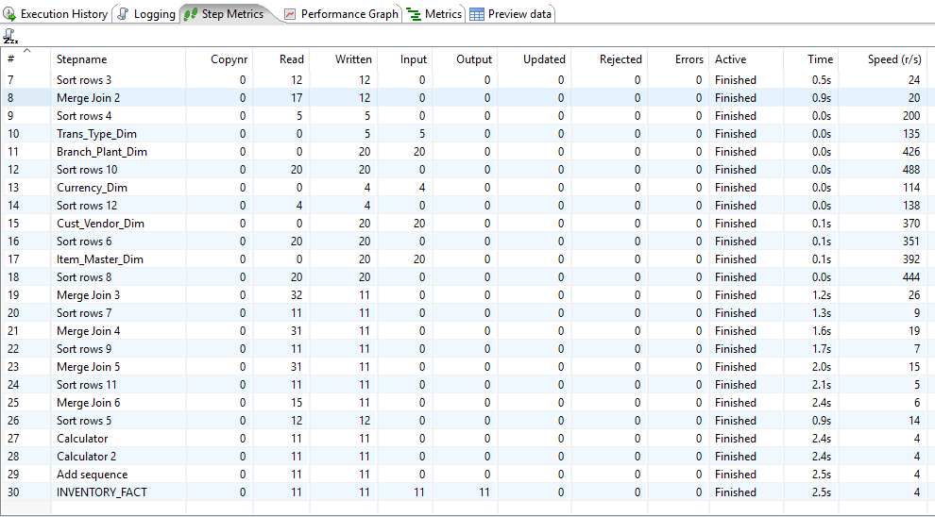

**Check Last INVETORY_FACT , Here 11 rows are written or inserted into the database. I checked the rows in sql developer.**

